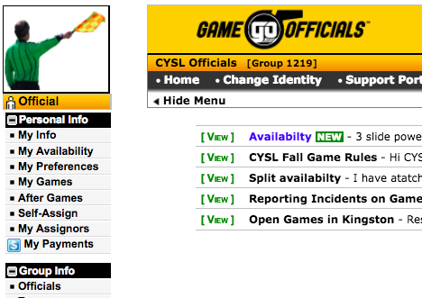From home page, select “After Games” on the left hand menu.

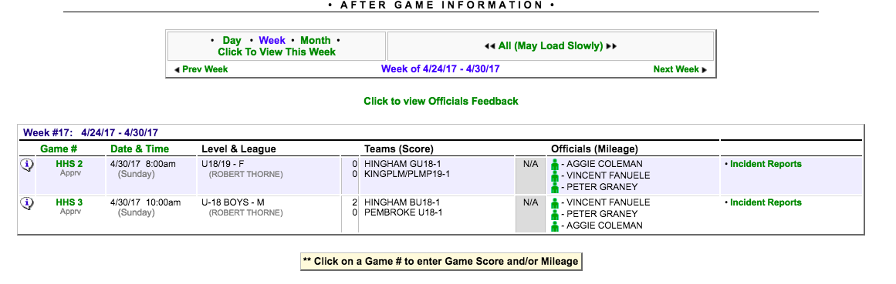

Select correct week using top box and click on the Game # of the game you wish to report in the second box.

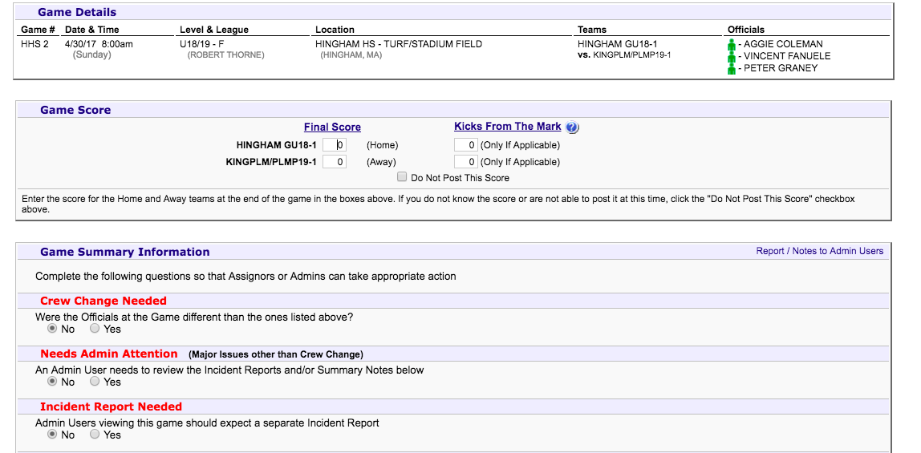

Add scores and answer the questions.

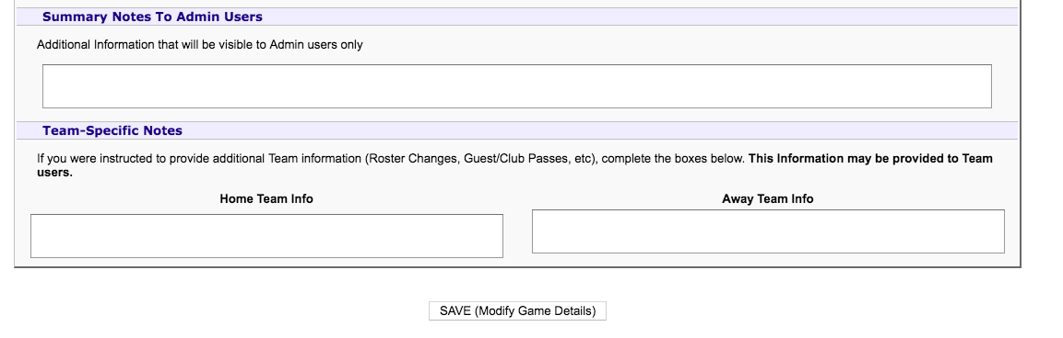

Use summary box to report if there is an incident report, or if coaches are missing pass cards or lanyards, or any roster or pass card issues. Also a good place to mention zero tolerance issues that did not reach the level of a card.

Don’t forget to “Save”