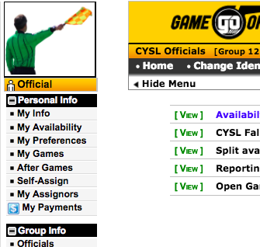
From the main page, select My Availability from the left hand menu.

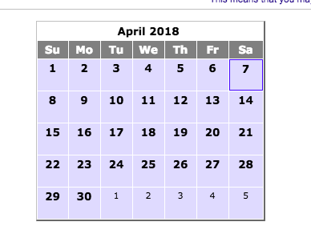
Select a date that you want to set availability for in the calendar. Use arrows at top of middle calendar to select the month and year.

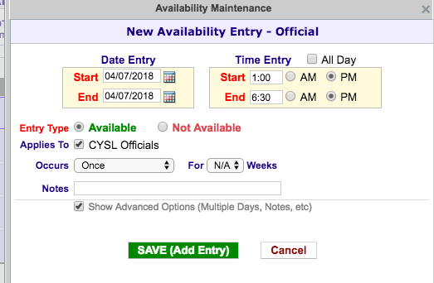
Enter availability for all day or part day using times. Be sure to hit the “Available” or “Not Available” button before “Save”

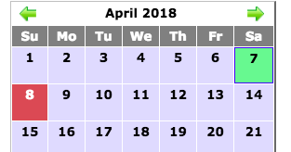
This is a correctly set available on the 7th of April and not available on the 8th of April.

