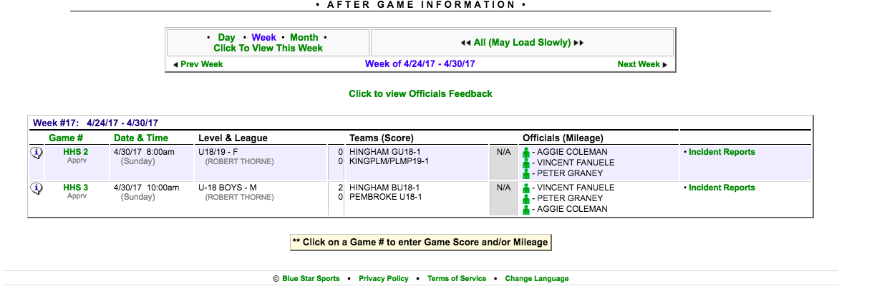
In “After Games” menu item, select “Incident Report” for the game being reported.

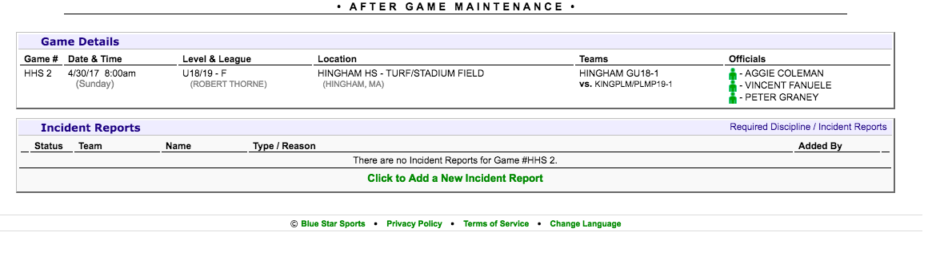
Select “Add a New Incident Report”

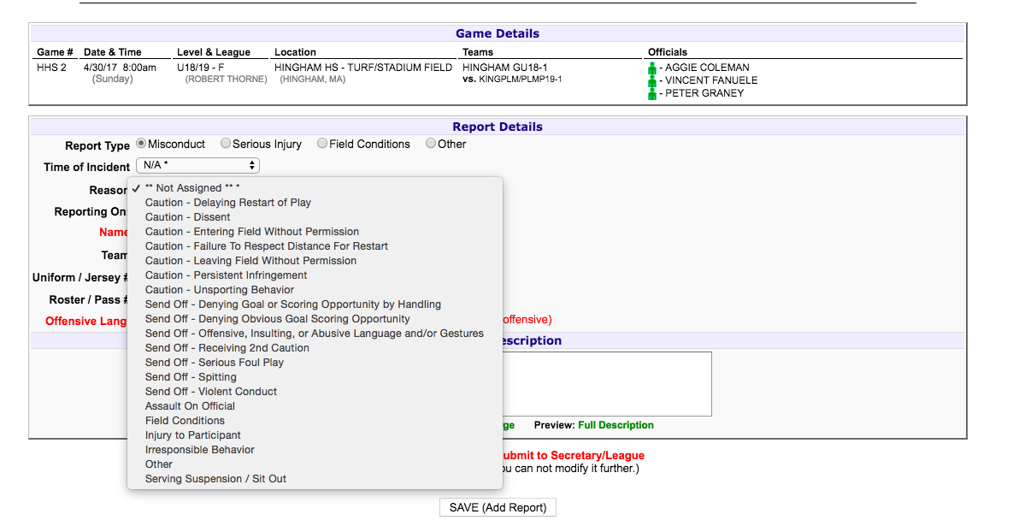
Use pull down menus and fill in information.

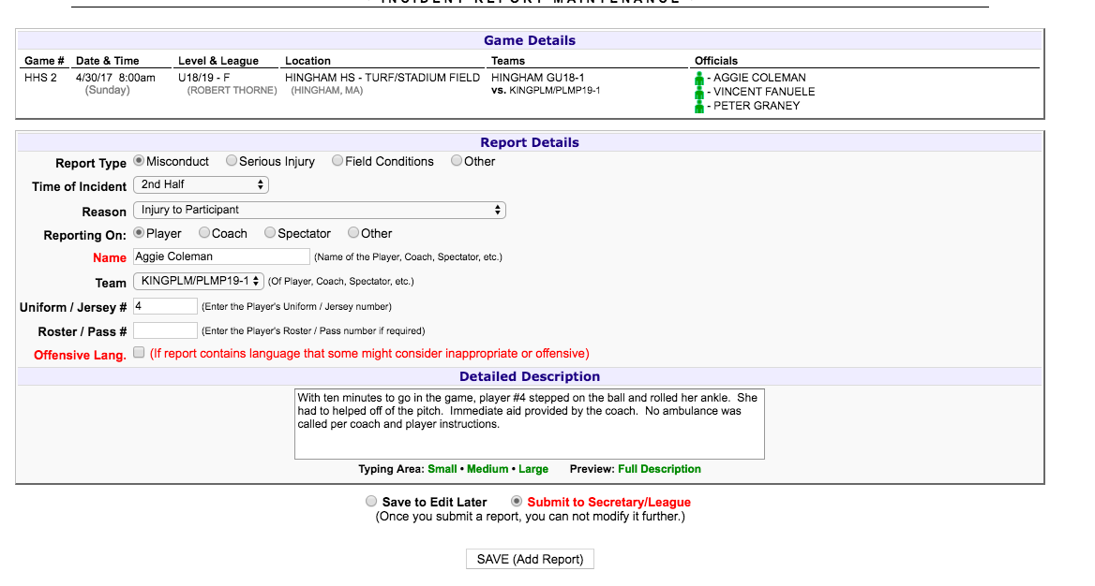
Be complete in your description of the incident. Be sure to “Submit” before you “Save”.
If unsure of language to use, ask your assignor.

Be certain to contact your assignor as soon as the game ends if there is an incident in your game.

