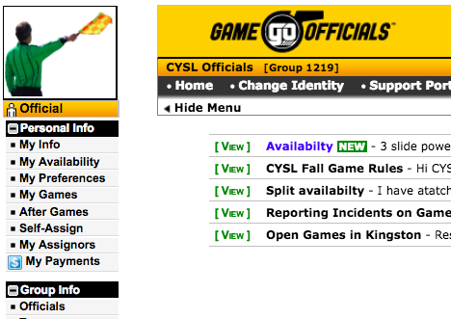
How to certify yourself for a League. You need to do this so that some assignors can find you for assignment.

Do not certify yourself for areas that you are willing to travel to.

Select “My Preferences” from the left hand call down menu.

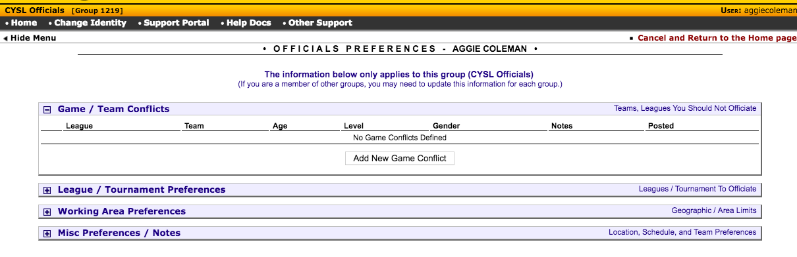
Select “League/Tournament Preferences”

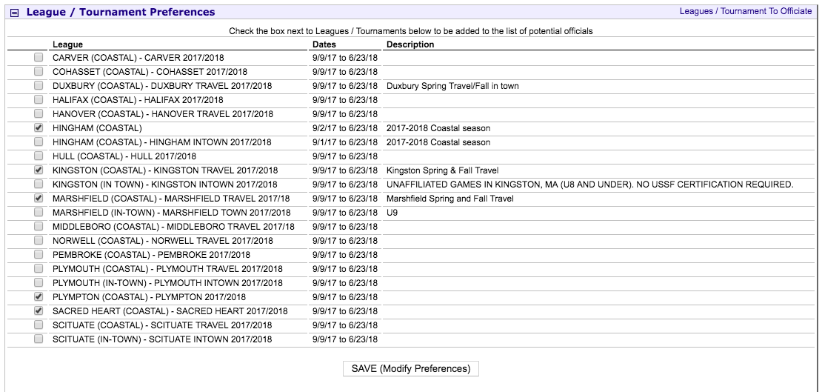

Select your Leagues and “Save”. If in doubt, discuss with your local assignor.

